**LAB 04**



**Fall 2022**

**CSE101L Computer Fundamentals Lab**

Submitted by: **Haris Khan**

Registration No. : **60032**

Class Section: **A**

“On my honor, as student of University of Engineering and Technology, I have neither given nor received unauthorized assistance on this academic work.”

Student Signature: ______________

Submitted to:

**Engr. Abdullah Hamid**

December 05, 2022

Department of Computer Systems Engineering

University of Engineering and Technology, Peshawar

***Slide no#01:***

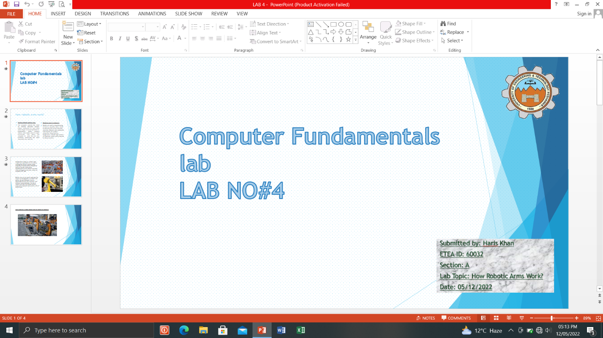

***Slide no#02:***

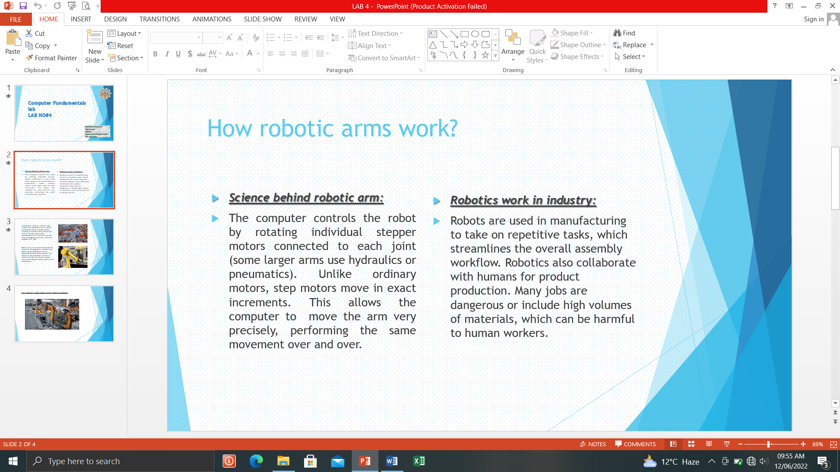

***Slide no#03:***

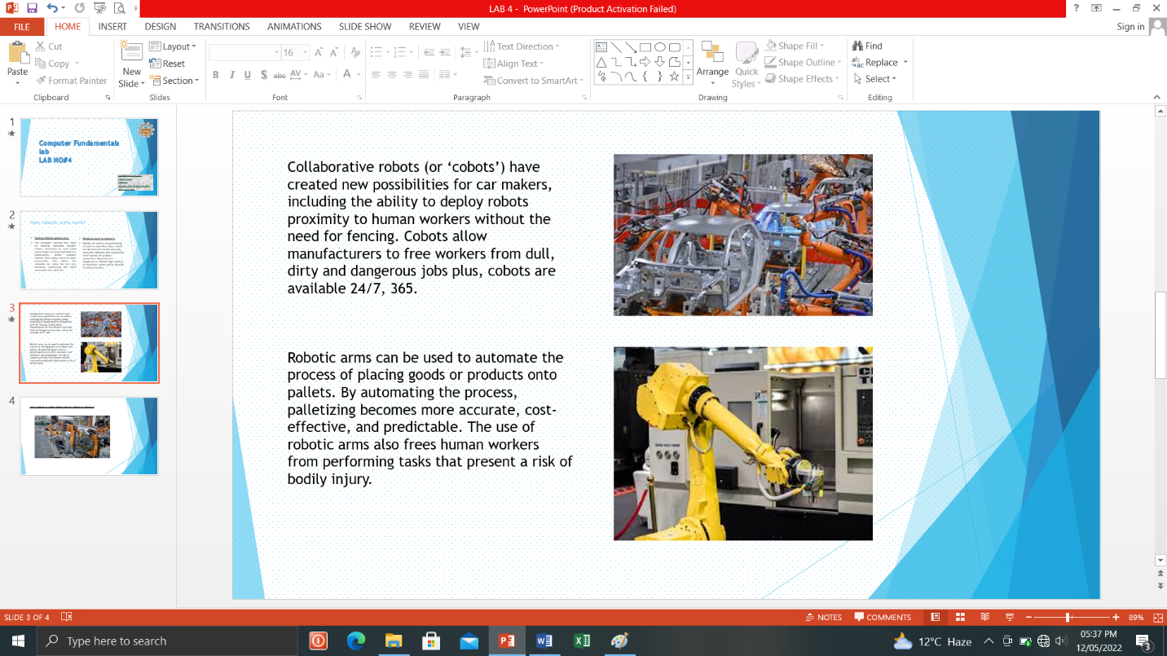

***Slide no#04:***

